TITANIC SURVIVORS PREDICTION – MACHINE LEARNING
Industrial Training Project Synopsis
Version 1.0
Industrial Training and Presentation (ECS791)
Degree
BACHELOR OF TECHNOLOGY (CSE)

PROJECT GUIDE:  Ms. Rohaila Naaz | SUBMITTED BY:  Manish Gupta (TCA1709110)

September, 2020



FACULTY OF ENGINEERING AND COMPUTING SCIENCES
TEERTHANKER MAHAVEER UNIVERSITY, MORADABAD

Table of Contents

1 Project Title 3
2 Domain 3
3 Problem Statement 3
4 Project Description 4
4.1 Scope of the Work 4
4.2 Project Modules 4
5 Implementation Methodology 5
Zero Level Data Flow Diagram (DFD) is as follows: 5
6 Technologies to be used 6
6.1 Software Platform 6
6.2 Hardware Platform 6
6.3 Tools 6
7 Advantages of this Project 6
8 Future Scope and further enhancement of the Project 7
9 Team Details 7
10 Conclusion 8
11 References 8

Project Title

Titanic Survivors Prediction – Machine Learning

Domain

IPython Notebook based Interactive Web Application – Jupyter Notebook for Modelling.

Problem Statement

The sinking of the Titanic is one among the foremost infamous shipwrecks in history. While there was some element of luck involved in surviving, it seems some groups of individuals were more likely to survive than others. In this project, my task as a Data Scientist is to build a predictive model that answers the question: “what sorts of people were more likely to survive?” using passenger data (ie name, age, gender, class , etc). The dataset used in this project can be obtained through Kaggle: https://www.kaggle.com/c/titanic

Machine Learning is the Art and Science of making the Machines Learn by themselves, it’s a systematic study of Computer Algorithms using Mathematical techniques like Statistics, Modeling and Computational Techniques like programming, it is a subset of Artificial Intelligence. Since we’re still in the phase of development of Narrow AI, ML is one of the hottest trends in Industry as of now and specialists are highly in demand by all Industries, it finds applications in Filtering, Computer Vision, and in NLP in the Linguistics, as Predictive Modelling in the Business Problems and Data Mining in such Industries. Machine Learning can be subdivided into 3 major categories, based on the type of problems the machine is solving and their nature, they are:
- Supervised Learning – Like Regression and Classification problems, Target Present
- Unsupervised Learning – Like Data Density and Clustering Problem, Untargeted
- Reinforcement Learning - Involving feedback based learning, out of experience
And, there are mixed types of learning problems that can be made out of the basic three one’s as mentioned above, however, these are most important one’s out there and the one’s that are most commonly used which form the basis of Machine Learning.

Project Description

This project is a simple yet powerful model that builds upon the basis of biggest maritime disasters in the history on the night of 15th of April, 1912 on Royal Mail Ship Titanic in which over 1500 people died and around 700 survived, the soul of the project is inspired from that incident and here, we’ve built a model to simply predict who will be the survivors of that incident which are traveling on RMS Titanic, we are provided with the Input Dataset containing details of all the Individuals on board and based on that, we are going to generate prediction dataset for the Survivors as the output of the Model in our Project. The domain of the Project is Machine Learning, however, since it being and extensive one, just going with Binary Classification problem (Supervised), here for now.

Scope of the Work

- Can be used cross platform any time subject to IDE availability as it’s an IPython Notebook.

- Can Predict Survivors of RMS Titanic with almost 72 percent accuracy in testing phase.

- The resultant predictions are almost instantly exported as another dataset by the model.

- However, unsuitable for Regression and Clustering Problems in the same domain.

- It is extensively used in the industry with manifestations as other business problems.

Project Modules

This Project runs on a Web Browser as an IPython ( Jupyter) Notebook which can be run on the Systems having the Anaconda IDE Installed, this Project’s notebook can then be successfully run on such machines on a Web Browser, calling the jupyter notebook command in CMD and importing the notebook thereby running the model with datasets.
In the Notebook, we can see the use of various Libraries as mentioned are being imported initially, then dataset is loaded an operations on it are performed as per ML Life Cycle and at the end, after building the model, the prediction dataset generated by the model can be seen being exported by the notebook.

Implementation Methodology

Zero Level Data Flow Diagram (DFD) is as follows:

PREDICTIONS
MODEL
DATA

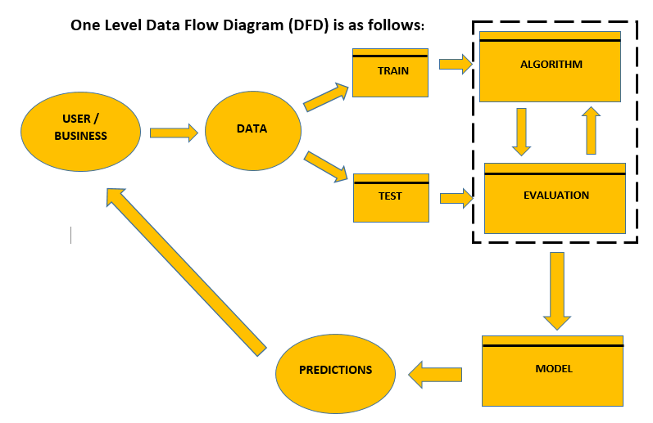

Technologies to be used
  - Software Platform
Libraries
- Pandas
- Numpy
- Matplotlib
- Scikit Learn

Back-end
- Python

  - Hardware Platform
- RAM : at least 4 GB of RAM
- Hard Disk : at least 5 GB of Disk Space on Hard Disk
- OS : Any Operating System
- IDE : Anaconda3 (4.3.1 x64) IDE – Python 3.6.0

  - Tools
Tool Name: IPython Notebooks (Jupyter Notebooks) by Anaconda (4.3.1 x64) IDE
Version: 4.3.1 x64 running on Python 3.6.0
Developer(s): Anaconda Inc. (Continuum Analytics Ltd.)
Written in: Python
Browser Used: Google Chrome (Recommended) or Mozilla Firefox

Advantages of this Project

- Can be used cross platform any time subject to IDE availability as it’s an IPython Notebook and can be enhanced by retraining model on same large dataset.

- Can Predict Survivors of RMS Titanic with almost 72 percent accuracy in testing phase.

- The Same model could be retrained for other similar problems of Binary Classification.

- The resultant predictions are almost instantly exported as another dataset by the model.

- It is extensively used in the industry with manifestations as other business problems.

- The Project doesn’t takes any user data or third party data apart from the input dataset for its usage, being concerned and inclined towards user or business privacy without denying user for accessing any feature of the Project.

Future Scope and further enhancement of the Project

It is easier to extend the Model that we have developed to similar or other related variety of problems and Business Applications. We could enhance the train dataset or the entire dataset for that matter to provide a much more better model, which means our model could work smoothly on enormously large datasets with the similar problem i.e. Titanic Survivors Dataset to get better insights on doubtful data and could predict over forthcoming data using attributes learnt by this model. The same modelling procedure, the entire process along with the Algorithm can be also applied to other relevant and closely related Business Problems like the Financial Agents Prediction for a Sales Company, Predicting Defective Items in a Production Line, Credit Card Defaulters Prediction, Customer Churn Prediction for Financial Products like Savings Bank Account for a Bank etc. and so many more, the similarity being all are Binary Classification Problem and the model we created here suits the need and the best and the fastest Algorithm for such would be Logistic Regression, however, Ensemble Techniques are always recommended.

Team Details

Group# | Course Name | Student ID | Student Name | Role | Signature
 | Machine Learning – Industrial Training and Presentation | TCA1709110 | Manish Gupta | Sole Developer, Designer and Tester.

Conclusion

The Titanic Survivors Prediction project developed is a Binary Classification Problem solved using Machine Learning Libraries of Python fully meets the objectives of the need for which it has been developed. The Model has reached a steady state where all possible identified and tested bugs have been eliminated. All sorts of Exploratory Analysis has been performed on the dataset prior to modelling and it was found that 342 passengers survived out of 891 on the ship, and the model was finally built using Logistic Regression Algorithm after rigorous testing using other techniques but LR was chosen as it performed better and was effective specific to this problem, finally I achieved approx. 74% accuracy on both train and test sets thus coming up as the Best Fitting Model, As so much as perfection is bothered no model is perfect ever and there square measure probabilities of improvement every moment. And, it could serve all similar variety of Binary Classification problems in the Industry provided it’s retained on new data.

References

a) Books
- Advanced Engineering Mathematics by Erwin Keyszig
- Higher Engineering Mathematics by BS Grewal and HK Das
- Linear Algebra by Gilbert Stang and Think Stats by Allen B Downey
- Software Engineering Principles and Practices by Roger Pressman

b) Websites
- www.google.com
- www.trainings.internshala.com
- www.youtube.com
- www.edx.com
- www.kaggle.com
- www.stackoverflow.com
- www.geeksforgeeks.com

End of Project Synopsis


